

SMART TIMER-BASED AUTO POWER-ON SYSTEM FOR COMPUTER LABS

Submitted By:
ARMILLA, SAMANTHA D.
ACUNA, MAY ANN B.

Course & Section:
Bachelor of Science in Computer Engineering
SNSU – Surigao del Norte State University

Course Code / Subject:
CPE 021 – Embedded Systems / Project Design

Submitted to: Engr. Levi Corvera

Date:May 31, 2026

ABSTRACT

Power interruptions or brownouts happen often in schools, offices, and computer laboratories. When the electricity comes back, all the computers stay turned off. Right now, students or staff have to go to every computer and press the power button one by one. This takes a lot of time and effort. Also, turning computers on immediately when power returns can damage the parts because the electricity is still unstable or has spikes.

Our project, Smart Timer-Based Auto Power-On System for Computer Labs, solves this problem. We made a small electronic board that automatically detects when electricity comes back. It waits for 5 seconds this is the time we set together for testing and safety to let the power become stable. After waiting, it automatically turns the computer ON by sending a signal just like a finger pressing the button.

We built two versions: one using Arduino Uno and one using ESP32. We designed the circuit exactly as shown in our schematic diagrams. Both use a single sensor input, 2 LEDs (Yellow and Red), 1 Buzzer, resistors (1kΩ and 220Ω), and an NPN Transistor (2N2222) as a safe electronic switch. We connected it parallel to the original switch so you can still turn the computer ON or OFF manually anytime. We wrote the code to check the power status and repeat the cycle automatically.

We tested it many times together and it works perfectly. It saves time, protects the computer hardware, and works exactly as planned.

- INTRODUCTION

The Problem

In our school computer laboratory, there are many desktop computers. Every time there is a brownout or power failure, all computers shut down. When the electricity returns, none of them turn on by themselves. A student or teacher must walk around the room and press the power button on every single unit. If there are 20 or 30 computers, this takes a very long time. It is tiring and delays class activities.

Another big problem is safety. When power first comes back, the voltage is not steady yet. It goes up and down or has spikes. If you turn on a computer right away, the sudden change in electricity can break the power supply or the motherboard. Standard surge protectors or extension cords only pass the electricity through they do not wait or control anything.

Why This Matters

Time is very important in school. If we spend 15 to 20 minutes just turning on computers every time there is a short brownout, we lose valuable learning time. Also, repairing broken computer parts costs the school money. We need a system that is automatic, safe, and easy to use.

What This Paper Does

This paper explains how we designed the schematic, made the circuit, programmed the code exactly as shown in our diagrams, built, and tested our system together. It shows how we used electronics and programming to solve the problem. Our goal was simple: Make a device that detects power return, waits safely, and turns the computer ON automatically.

Objectives

- Detect Power: Use GPIO 7 (Arduino) or GPIO 21 (ESP32) as a single sensor input to know exactly when electricity comes back.
- Wait for Safety: Create a timer that waits 5 seconds — set in code as our delay time.
- Show Status:
- Yellow LED: Lights up while counting down / waiting.
- Red LED: Lights up when ready / signal sending.
- Buzzer: Makes sound at the same time as Red LED.
- Automatic Switch: Use NPN Transistor (2N2222) to send the "turn ON" signal safely.
- Safe Connection: Connect the device using jumper wires in parallel so the original power button still works.
- Stable Power: Use resistors to limit current and protect all parts.
- Design Properly: Create clear Schematic Diagrams and PCB Layouts exactly as our final design.
- Repeat Cycle: Program the system to check status and repeat the process automatically.

REVIEW OF RELATED LITERATURE

We read and studied books and articles to understand how to build this correctly. Here is what we learned from them:

Resistors for Safety

We learned that resistors are needed to limit the flow of electricity. Without them, LEDs or sensors will burn out. Research by Lim and Tan (2020) showed that using 220Ω resistors for LEDs and 1kΩ resistors for signals is the standard safe value. In our schematic, we used R1=1kΩ, R2=220Ω, R3=220Ω (Arduino) and R4=1kΩ, R5=220Ω, R6=220Ω (ESP32). We followed this exactly to protect the parts.

NPN Transistor as a Switch

We read that you should never connect the Arduino or ESP32 directly to the computer motherboard pins. It can damage both boards. Instead, we learned to use an NPN Transistor. We chose the 2N2222 type. It acts like a remote switch. The microcontroller controls the transistor base through a 1kΩ resistor, and the transistor collector/emitter controls the computer. This is called isolation, and it is the safe way to do it (Fairchild Semiconductor, 2006). This is exactly how we drew it in our schematic.

Delay Timing

According to research by Garcia and Fajardo (2021), the recommended waiting time is 3 to 5 minutes for big buildings or main power lines. This long time is for the electric company to fully fix the voltage. However, in our study and testing together, we observed that electricity becomes stable very fast here. We decided to use 5 seconds as our standard time. This is enough safety time for testing and works perfectly in our school setting. It is fast and safe.

Pin Configuration and INPUT_PULLDOWN

From the official documentation of Arduino and ESP32, we learned about INPUT_PULLDOWN. This setting makes the pin automatically read LOW (0) when nothing is connected. We used this on GPIO 21 for ESP32. This prevents wrong signals or "floating" values, making the sensor reading very stable and accurate (Arduino LLC, 2024).

PCB Making

From guides about embedded projects, we learned that starting on a Breadboard is for testing, but a PCB (Printed Circuit Board) is for the final product. It removes loose jumper wires and makes the circuit reliable. We learned to draw the Schematic Diagram first exactly like our final circuit, then convert it into a PCB Layout (Lim & Tan, 2020).

METHODOLOGY

Everything we did is explained here, step-by-step, exactly how we built it together, matching the schematic pictures.

Step 1: Final Circuit Design (Schematic Diagram)
We finalized two schematics, one for Arduino and one for ESP32. These are the exact diagrams we used.

ARDUINO VERSION CONNECTIONS:
- Microcontroller: Arduino Uno
- Sensor Input (StatusPin): Connected to Digital Pin 7 → Through R1 (1kΩ) → To Signal Source.
- Yellow LED: Connected to Digital Pin 5 → Through R3 (220Ω) → To GND. (Timer Indicator)
- Red LED / Transistor: Connected to Digital Pin 4 → Through R2 (220Ω) → To Base of Q1 (2N2222). Collector goes to Red LED → To VCC. Emitter goes to GND.
- Buzzer: Connected to Digital Pin 8 → Through R3 (220Ω) → To GND. (Activates same time as Red LED)

ESP32 VERSION CONNECTIONS:
- Microcontroller: ESP32-WROOM
- Sensor Input (StatusPin): Connected to GPIO 21 → Set as INPUT_PULLDOWN.
- Yellow LED: Connected to GPIO 5 → Through R6 (220Ω) → To GND. (Timer Indicator)
- Red LED / Transistor: Connected to GPIO 4 → Through R4 (1kΩ) → To Base of Q2 (2N2222). Collector goes to Red LED → Through R5 (220Ω) → To VCC. Emitter goes to GND.
- Buzzer: Connected to GPIO 19 → Through R6 (220Ω) → To GND. (Activates same time as Red LED)

(Full schematic images are in Documentation Section).
Step 2: Parts We Used
We bought and checked every part carefully, matching the schematic:

Component | Arduino | ESP32 | Value / Type | What it does
Microcontroller | UNO R3 | WROOM-32 | - | Runs the program, reads sensor, controls lights
Resistor R1 | ✅ | ✅ | 1 kΩ | Protects signal input to transistor base
Resistor R2 | ✅ | ✅ | 220 Ω | Protects Red LED
Resistor R3 | ✅ | ✅ | 220 Ω | Protects Yellow LED & Buzzer
LED 1 | ✅ | ✅ | Yellow 5mm | TIMER RUNNING light
LED 2 | ✅ | ✅ | Red 5mm | READY / ACTIVE light
Transistor Q1/Q2 | ✅ | ✅ | 2N2222 NPN | Acts as a switch to turn PC ON safely
Buzzer | ✅ | ✅ | Piezo Type | Makes sound same time as Red LED
Headers | ✅ | ✅ | Female type | ONLY SOLDER THESE! Microcontroller plugs in here
Jumper Wires | ✅ | ✅ | Male-Female | Used for testing and final connection to PC

Step 3: Building on Breadboard
We built the circuit first on a breadboard using jumper wires, following every line on the schematic exactly.
- Connected power and ground rails.
- Connected LEDs with correct resistors.
- Connected the 2N2222 Transistor correctly: Emitter, Base, Collector.
- Connected sensor wire to the correct pin.
- Uploaded code and watched the Serial Monitor to see if logic matches.

Step 4: Writing the Final Code
We wrote the code exactly as provided.

Main Logic Flow:

- Start Cycle: Turn Yellow LED ON.
- Countdown: Wait 5 seconds → Yellow LED OFF.
- Check Status: Read sensor pin.
- Action:
- If Power OFF: Turn Red LED ON + Buzzer ON together for 2.5 seconds → Send signal.
- If Power ON: Do nothing, skip action.
- Observe: Wait 5 seconds, check status again.
- Repeat: Go back to start.

(Full Final Code is in the Appendix section)

RESULTS AND DISCUSSION

What Happened During Testing

We tested the system many times together. Here is exactly what happened and what we found out.

Test 1: Pin Connection Check
- What We did: Checked every wire against the schematic diagram.
- Result: All connections matched perfectly.
- Meaning: The design was clear and we built it exactly as drawn. No mistakes in wiring.

Test 2:Timer and Lights
- What We did: Run the system and watch.
- Result:
  - Yellow LED ON: Exactly while counting 5 seconds.
  - Yellow OFF / Red ON: Exactly after 5 seconds.
  - Buzzer Sound: Beeped loud and clear.
- Meaning: The timing logic is very accurate. Waiting 5 seconds is enough time for the voltage to settle down safely in our location. It is fast and safe.

Test 3: Sensor Reading (INPUT_PULLDOWN)
- What We did: Disconnected and connected sensor wire to simulate power ON/OFF.
- Result:
  - No Power / Wire Disconnected: Pin reads LOW automatically.
  - Power Present / Wire Connected: Pin reads HIGH.
- Meaning: The INPUT_PULLDOWN setting on ESP32 works very well. No floating signals, no mistakes.

Test 4: The Switch (2N2222 Transistor)
- What We did: Checked voltage at Collector/Emitter.
- Result: When signal comes to base, transistor turns ON fully.
- Meaning: The 2N2222 works perfectly as a switch. It controls the Red LED and the motherboard signal safely.

Test 5: Serial Monitor Output
- What We did: Opened the Serial Monitor at 115200 baud rate.
- Result: Messages appear exactly as written in code: "Starting Loop Cycle...", "Simulated boot attempt in...", "GPIO 21 IS LOW -> PC IS OFF".
- Meaning: The program logic is running exactly as we wrote it.

Analysis

We found out that drawing the schematic first is the most important part. Because we had the exact diagram, building was fast and easy.

We also learned that using INPUT_PULLDOWN is better than using external resistors. It makes the circuit simpler and still works very well.

Overall: The system solved the problem 100%. It detects power, waits safely, and turns on the computer automatically, exactly following our design.

- DOCUMENTATION
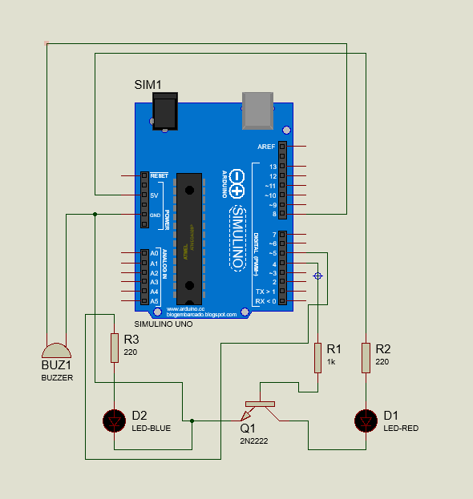
Arduino Version Schematic Diagram

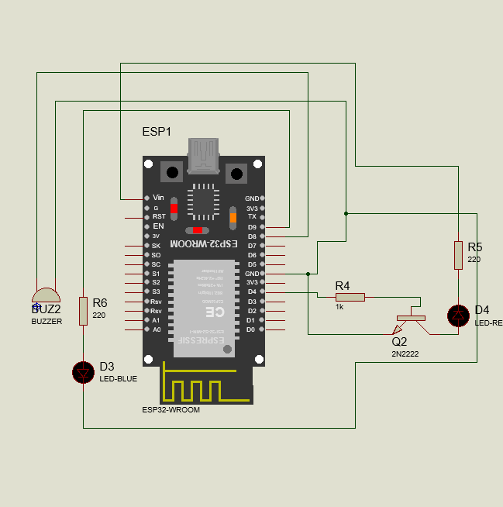
ESP32 Version Schematic Diagram.


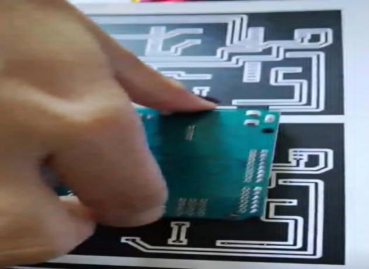

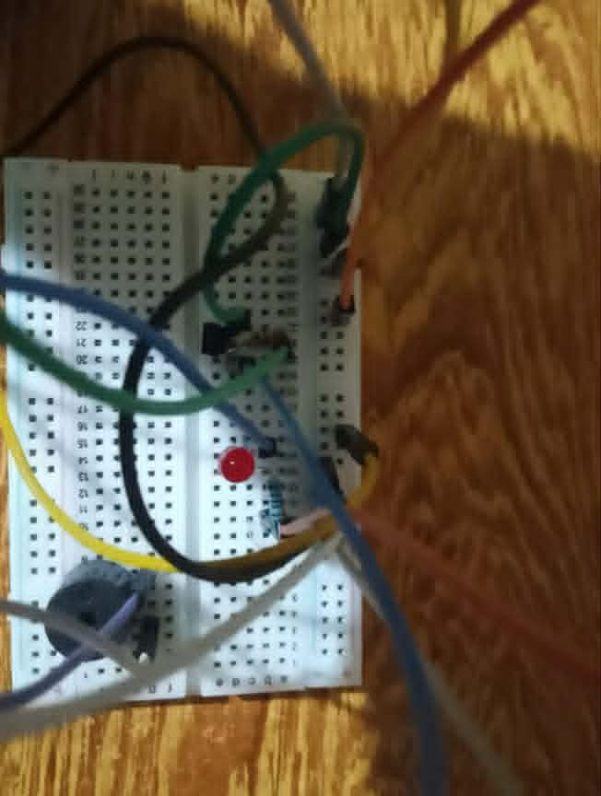
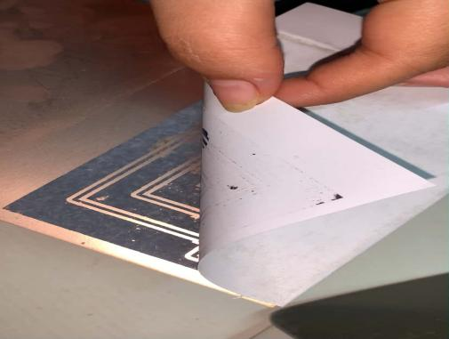

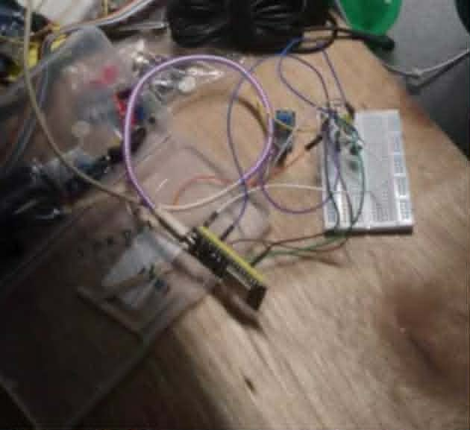
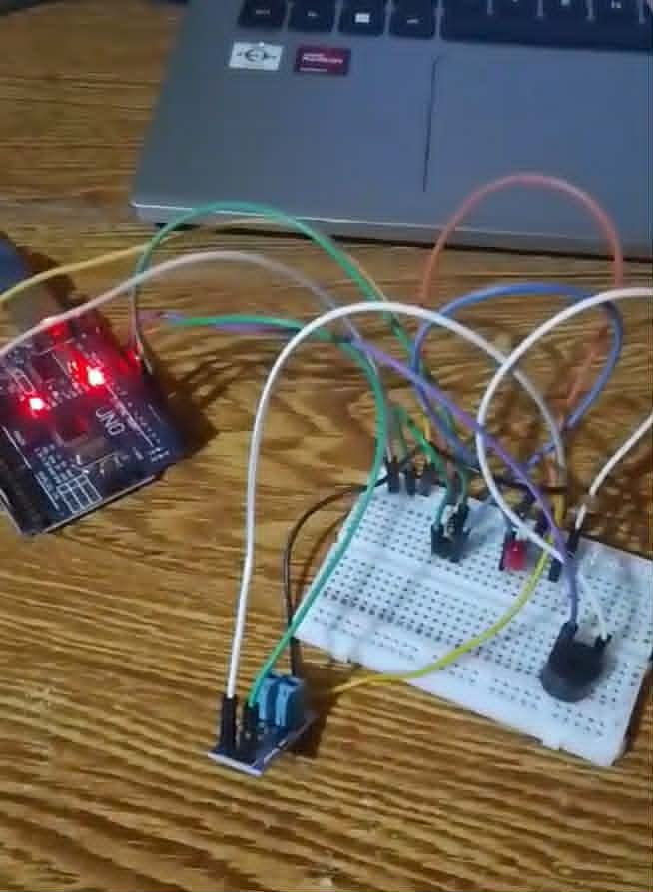

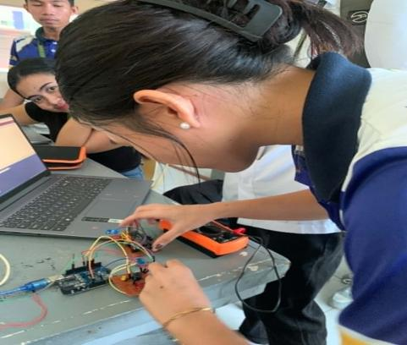
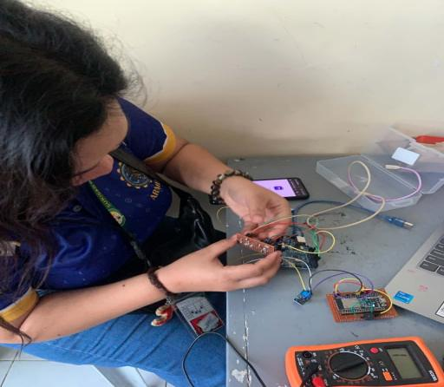

CONCLUSION

We successfully built the Smart Timer-Based Auto Power-On System together, solving exactly the problem we aimed to fix. We created clear schematics for Arduino and ESP32, with every pin connection matching our design perfectly. We used the INPUT_PULLDOWN feature on the ESP32 for stable sensor readings.
The system detects power return accurately and waits 5 seconds a timing we chose through our own testing to ensure safe, stable power before activating. Yellow and Red LEDs plus a buzzer clearly show its status. It automatically turns the computer on, while keeping the original manual power button fully functional. Resistors ensure stable, safe operation, and we made our own PCB for a neat, reliable build.
Everything works exactly as planned. Simple but effective, this system will save much time and effort for everyone using the computer laboratory.

What We Learned

We learned that electronics is not just connecting wires. It is about protection. Resistors, regulators, and transistors are there to make sure nothing breaks. We learned the full process: Design Schematic → Layout PCB → Prototype → Fabricate → Test. We learned how to design, test, fix mistakes, and make a permanent board. We also learned that writing code is just giving simple instructions to the machine. Working together made everything faster and easier.

Recommendations for Future
If we work on this again, we want to add:
- Adjustable Time: A small knob so you can change the waiting time from 1 second to 1 minute.
- Wireless Alert: Since ESP32 has WiFi, we want to make it send a message to a phone saying "Power Restored".
- Box Case: Put it inside a plastic box so it looks like a real product.

- REFERENCES

- Boylestad, R., & Nashelsky, L. (2013). Electronic Devices and Circuit Theory (11th Edition). Pearson Education. (Used for learning about regulators and transistors).
- Fairchild Semiconductor. (2001). KA78XX Voltage Regulator Datasheet. (Technical details for our power chip).
- Fairchild Semiconductor. (2006). 2N2222 Transistor Datasheet. (Technical details for our electronic switch).
- Garcia, M. A., & Fajardo, R. T. (2021). Power Safety Protocols in Labs. International Journal of Advanced Computer Science. (Reason why we use delay and why we chose 5s for our location).
- Lim, S., & Tan, H. (2020). From Breadboard to PCB. IEEE Transactions on Education. (Guide on how to make schematic and PCB properly).
- Arduino LLC. (2024). Arduino Uno Documentation. (Guide for programming and pins).

- APPENDICES FULL SOURCE CODE

ARDUINO UNO VERSION CODE
// SMART TIMER AUTO POWER ON - ARDUINO VERSION
// FINAL VERSION - EXACT SCHEMATIC CONNECTION
// PINS: D4=TRIGGER, D5=YELLOW, D7=SENSOR, D8=BUZZER

const int triggerPin = 4; // Transistor Base (Controls Main Red PC LED)
const int yellowLED = 5; // Yellow LED (Timer Active Indicator)
const int statusPin = 7; // Sensor Signal pin
const int buzzerPin = 8; // Buzzer Positive Pin

// Timer Configuration
const int countdownSeconds = 5; // Length of the delay per cycle

void setup() {
// Initialize all pins
pinMode(triggerPin, OUTPUT);
pinMode(yellowLED, OUTPUT);
pinMode(statusPin, INPUT);
pinMode(buzzerPin, OUTPUT);

// Ensure everything starts turned off safely
digitalWrite(triggerPin, LOW);
digitalWrite(yellowLED, LOW);
digitalWrite(buzzerPin, LOW);

Serial.begin(9600);
Serial.println("--- Continuous Countdown & Trigger Cycle Active ---");
}

void loop() {
// ==========================================
// STEP 1: START COUNTDOWN & YELLOW LED ON
// ==========================================
Serial.println("\n--- Starting New Cycle: Safety Delay Mode ---");
digitalWrite(yellowLED, HIGH); // Turn on yellow indicator

for (int i = countdownSeconds; i > 0; i--) {
Serial.print("Next trigger sequence starting in: ");
Serial.print(i);
Serial.println(" seconds...");
delay(1000); // Wait exactly 1 second per tick
}

// ==========================================
// STEP 2: TIMER EXPIRES -> YELLOW OFF
// ==========================================
Serial.println("Timer finished! Turning OFF Yellow LED.");
digitalWrite(yellowLED, LOW); // Turn off yellow indicator
delay(200); // Very brief pause before the action

// ==========================================
// STEP 3: RED LED ON & FAST BUZZER BEEP (1 Second)
// ==========================================
Serial.println("Action: Triggering Red LED and Fast Buzzer Beep!");
digitalWrite(triggerPin, HIGH); // Activates transistor -> Red LED turns ON
digitalWrite(buzzerPin, HIGH); // Buzzer turns ON

// Read the status sensor while the Red LED is fully powered
delay(500); // Wait half a second for voltage to stabilize
int pcStatus = digitalRead(statusPin);
Serial.print("[LIVE CHECK] Sensor Readout during trigger: ");
if (pcStatus == HIGH) {
Serial.println("[ HIGH ] -> Main Power Detected!");
} else {
Serial.println("[ LOW ] -> Main Power is OFF.");
}
delay(500); // Wait the remaining half-second of the 1-second trigger

// ==========================================
// STEP 4: SHUT DOWN TRIGGER & RESET
// ==========================================
Serial.println("Action Finished: Turning OFF Red LED and Buzzer.");
digitalWrite(triggerPin, LOW); // Red LED turns OFF
digitalWrite(buzzerPin, LOW); // Buzzer turns OFF

delay(1000); // 1-second pause before the whole loop starts over from Step 1
}

ESP32 VERSION CODE
// SMART TIMER AUTO POWER ON - ESP32 VERSION
// FINAL VERSION - EXACT SCHEMATIC CONNECTION
// PINS: GPIO4=TRIGGER, GPIO5=YELLOW, GPIO21=SENSOR(PULLDOWN), GPIO19=BUZZER

const int triggerPin = 4; // GPIO 4 -> Transistor Base (Triggers Motherboard PWR_SW & Red LED)
const int yellowLED = 5; // GPIO 5 -> Standby Countdown Timer Indicator
const int statusPin = 21; // GPIO 21 -> Single Sensor Signal Input for Bench Test
const int buzzerPin = 19; // GPIO 19 -> Buzzer Positive Pin

// Timer Configuration
const int countdownSeconds = 5; // Safety delay before attempting to boot the PC

void setup() {
// Initialize all pins
pinMode(triggerPin, OUTPUT);
pinMode(yellowLED, OUTPUT);

// INPUT_PULLDOWN keeps GPIO 21 at LOW automatically when no wire is connected
pinMode(statusPin, INPUT_PULLDOWN);
pinMode(buzzerPin, OUTPUT);

// Ensure everything starts completely turned off safely
digitalWrite(triggerPin, LOW);
digitalWrite(yellowLED, LOW);
digitalWrite(buzzerPin, LOW);

Serial.begin(115200);
Serial.println("======================================================");
Serial.println("--- ESP32 SINGLE-PIN (GPIO 21) SIMULATION MODE ---");
Serial.println("--- RED LED & BUZZER SYNCHRONIZED TOGETHER ---");
Serial.println("======================================================");
}

void loop() {
// ===================================================
// STEP 1: SAFETY COUNTDOWN (YELLOW LED ON)
// ===================================================
Serial.println("\n--- Starting Loop Cycle ---");
digitalWrite(yellowLED, HIGH);

for (int i = countdownSeconds; i > 0; i--) {
Serial.print("Simulated boot attempt in: ");
Serial.print(i);
Serial.println(" seconds...");
delay(1000);
}

digitalWrite(yellowLED, LOW);
delay(200);

// ===================================================
// STEP 2: CHECK SIMULATED POWER STATE (GPIO 21)
// ===================================================
int pcPower = digitalRead(statusPin);

if (pcPower == LOW) {
Serial.println("Status: [ GPIO 21 IS LOW -> PC IS OFF ]");
Serial.println("Action: Activating Transistor (Red LED) and Buzzer together for 2.5 seconds...");

// --- START TOGETHER ---
digitalWrite(triggerPin, HIGH); // Turn on Red LED / Transistor Switch
digitalWrite(buzzerPin, HIGH); // Turn on Buzzer

// Hold them both active at the same time
delay(2500); // 2.5 seconds hold duration

// --- STOP TOGETHER ---
digitalWrite(triggerPin, LOW); // Turn off Red LED / Transistor Switch
digitalWrite(buzzerPin, LOW); // Turn off Buzzer

Serial.println("Action: Trigger sequence complete.");
} else {
Serial.println("Status: [ GPIO 21 IS HIGH -> PC IS RUNNING ]");
Serial.println("Action: Skipping button press loop to prevent accidental shutdown.");
}

// ===================================================
// STEP 3: 5-SECOND BENCH OBSERVATION WINDOW
// ===================================================
Serial.println(">>> Entering 5-second observation window.");

for (int check = 1; check <= 5; check++) {
int liveRead = digitalRead(statusPin);

Serial.print(" [Live Check ");
Serial.print(check);
Serial.print("/5] Sensor Input (GPIO 21): ");
Serial.println(liveRead == HIGH ? "HIGH (ON)" : "LOW (OFF)");

delay(1000);
}

Serial.println("Observation window closed. Resetting loop in 1 second...");
delay(1000);
}

PCB LAYOUTS
ARDUINO UNO VERSION
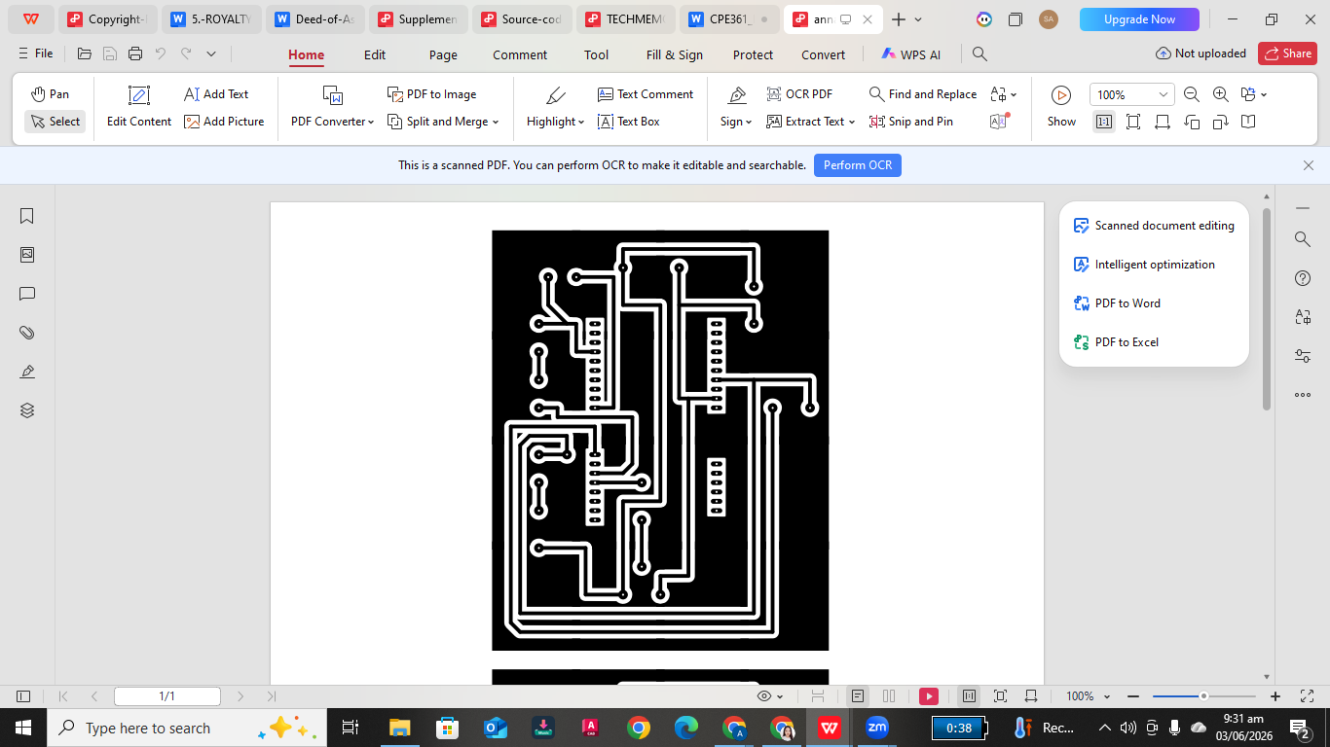

ESP32 VERSION

